ATM Simulation System

Group Members
Huzaifa Ahmed Bari (24K-0847)
Shoaib Hayat (24K-1028)
Suffian Khan (23K-0929)

Submission Date
24 November 2025

1. Executive Summary
This project implements a complete ATM System using Assembly Language with the Irvine32 library on the x86 architecture. The system simulates real ATM functionality including user authentication, balance inquiry, deposits, withdrawals, currency conversion, and administrative control. The aim of the project is to demonstrate low-level programming concepts, logical flow control, and user interaction handling in a structured and secure manner.

2. Introduction
The ATM System is designed to replicate basic banking operations in a console-based environment using Assembly Language. It provides separate access for customers and administrators, ensuring controlled access to sensitive functions. This project helps in understanding system-level programming, memory handling, input/output operations, and procedural design using the Irvine32 library.

3. Project Description
The project consists of two main portals: Customer Portal and Admin Portal. The customer can view balance, deposit money, withdraw cash, convert balance into different currencies, and view current exchange rates. The admin can manage system settings such as resetting PIN, updating currency exchange rates, refilling ATM cash, and viewing system rates. Security is enforced through PIN and password authentication with retry limits.

4. Methodology
The system follows a menu-driven approach. User input is read using Irvine32 input functions and decisions are handled through conditional jumps and comparisons. Separate labels are used for each functional module to ensure clarity and avoid label conflicts. Error handling and success notifications are provided to enhance user interaction. Delay and screen clearing mechanisms are used for better interface flow.

5. Project Implementation
The project is implemented using MASM with Irvine32.inc library. Data such as balance, PIN, and exchange rates are stored in the data segment. Functional modules include:
- Main Menu Navigation
- Customer Authentication with Retry Limit
- Admin Authentication
- Transaction Operations (Deposit, Withdraw)
- Balance Display
- Currency Conversion
- Viewing Exchange Rates
- PIN Reset and Rate Modification

6. Results
The system successfully performs all ATM operations in real-time through console interaction. Customers can securely access their accounts and perform transactions, while the admin can manage and monitor the system efficiently. The retry limit feature prevents unauthorized access, and currency conversion works based on dynamically adjustable rates.

Screenshots

Main Menu
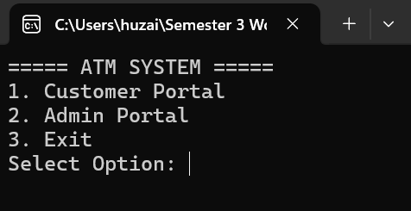

Customer Portal
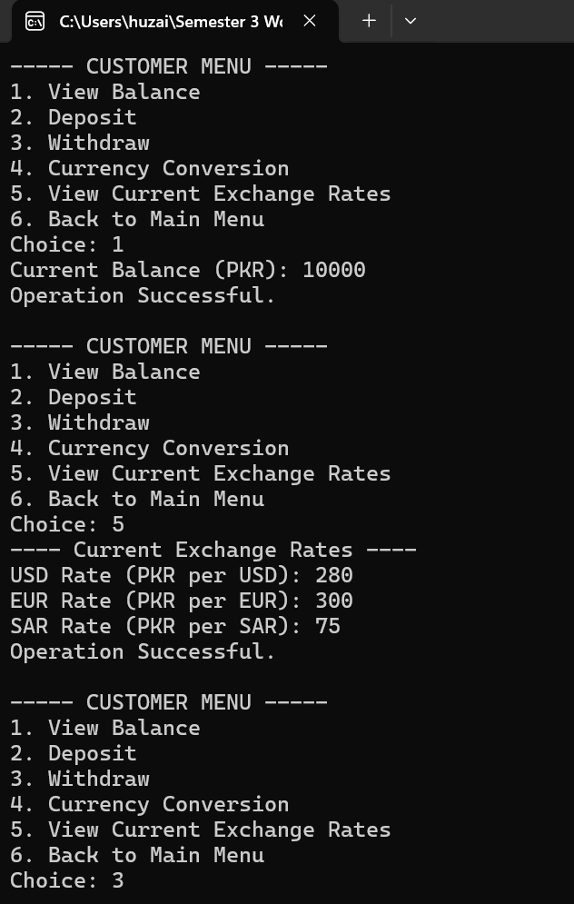

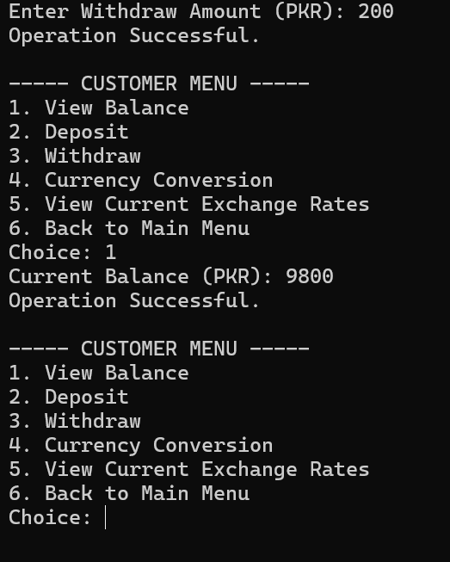

Admin Portal
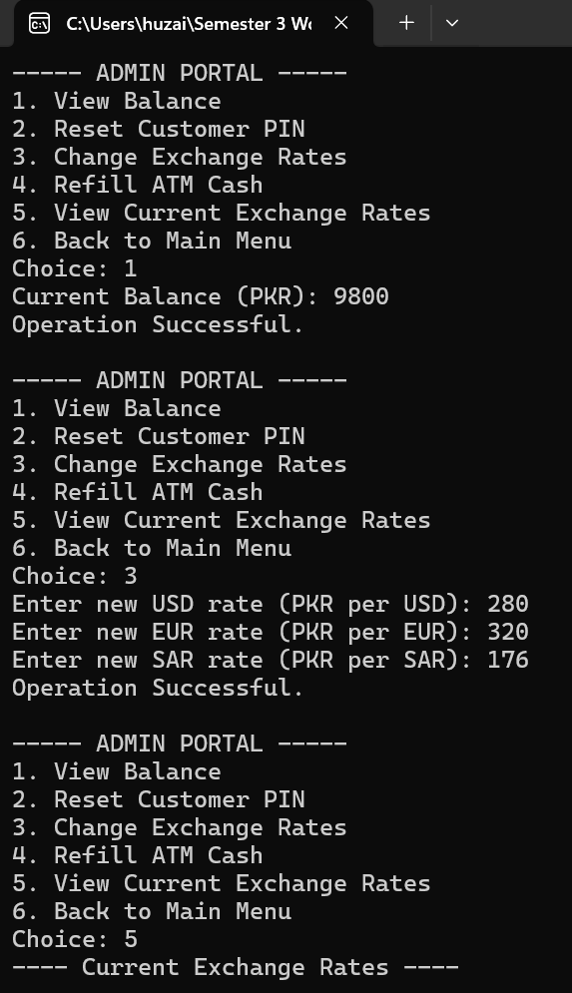

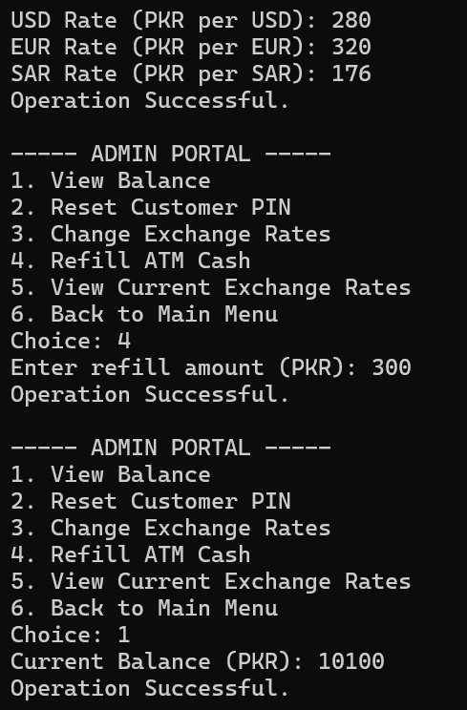

7. Conclusion
The ATM System project effectively demonstrates the application of assembly language in developing a realistic banking simulation. It highlights the importance of logical control, user authentication, and structured programming. The project fulfills all required functionalities and provides a strong foundation for further enhancements such as transaction history or account locking mechanisms.

